Call for Papers

Love and Lenses: Photographic Couples, Gender Relationships, and Transatlantic Networks in the Long Nineteenth Century

12th – 13th October 2023
Maison Française d'Oxford and Rothermere American Institute, University of Oxford

The Maison Française d'Oxford and the Rothermere American Institute are delighted to invite paper proposals on the theme: ‘Love and Lenses: Photographic Couples, Gender Relationships, and Transatlantic Networks in the Long Nineteenth Century.’ This conference is being organised by Dr. Emily Brady (Broadbent Junior Research Fellow, Rothermere American Institute) and Martyna Zielinska (DPhil, Université de Paris Cité, LARCA).

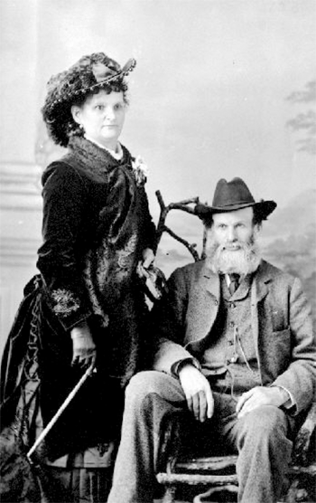
This two-day conference invites papers that explore photographic partnerships as a main object of study. Since the invention of the camera, men and women – spouses, friends, members of the same family – have learned and practiced photography together for business, pleasure, educational and scientific purposes. This conference aims to bring new light on how the practice of photography could bear an impact on gender relationships in the long nineteenth century. A wide geographic scope will enable discussion of the differences in women’s emancipatory contexts, and to discuss the legal and social frameworks of professional photographic partnerships. As such, we look forward to welcoming papers that include both literal interpretations of ‘photographic couples’ and more abstract ideas / associations.
Richard and Hannah Maynard

The conference will include keynotes from Professor Elizabeth Edwards (Research Affiliate, ISCA, University of Oxford) and Dr. Carolin Görgen (Associate Professor of American Studies, Sorbonne Université). We are keen to programme papers across multiple disciplines, including (but not limited to): History, Art History, American Studies, and Gender Studies.

Please submit a paper title, 250-word abstract and a copy of your CV. The deadline for submission is the 21st of July 2023. This should be sent to: emily.brady@rai.ox.ac.uk and martyna.zielinska@etu.u-paris.fr

Limited funding is available to assist with travel and accommodation costs. If you wish to apply for this, please include a brief justification in your application.

